**EX NO 11D: Date:28/10/2024**

**Roll No:231901002**

**REMOTE PROCEDURE CALL FOR SORTING AN ARRAY - XMLRPC**

**Aim:**

To Implement an XML RPC code for sorting array

**Algorithm:**

**Server side:**

1. Import `SimpleXMLRPCServer` and `SimpleXMLRPCRequestHandler` from the `xmlrpc.server` module.
2. Create a custom `RequestHandler` class that extends `SimpleXMLRPCRequestHandler` and set `rpc_paths` to `('/RPC2',)`.
3. Instantiate the server with `localhost` and port `8000`, using the custom `RequestHandler`.
4. Register introspection functions to allow clients to discover available methods.
5. Define the `sort_array` function that checks if all elements in the array are numbers and sorts the array.
6. Register the `sort_array` function with the server, associating it with the name `'sort_array'`.
7. Start the server with `serve_forever()`, making it listen for and handle incoming XML-RPC requests.

**Client side:**

1. Import `xmlrpc.client` to interact with the XML-RPC server.
2. Define the server URL (`http://localhost:8000`) and create a `ServerProxy` object to communicate with the server.
3. Prompt the user to input a list of numbers separated by spaces.
4. Attempt to convert the input string into a list of floating-point numbers, and handle any `ValueError` if the input is invalid.
5. If the input is invalid, print an error message and exit the program.
6. Call the `sort_array` function on the server proxy with the list of numbers.
7. Print the sorted array returned from the server.

**Program:**

**Server side:**

from xmlrpc.server import SimpleXMLRPCServer from xmlrpc.server import SimpleXMLRPCRequestHandler class RequestHandler(SimpleXMLRPCRequestHandler): rpc_paths = ('/RPC2',)

server = SimpleXMLRPCServer(('localhost', 8000), requestHandler=RequestHandler) server.register_introspection_functions() def sort_array(arr): if not all(isinstance(i, (int, float)) for i in arr):

raise ValueError("All elements of the array must be numbers.") return sorted(arr) server.register_function(sort_array, 'sort_array') print("Server is running on [http://localhost:8000"](http://localhost:8000/)) server.serve_forever()

**Client side:**

import xmlrpc.client

server_url = "[http://localhost:8000"](http://localhost:8000/) proxy = xmlrpc.client.ServerProxy(server_url) input_string = input("Enter a list of numbers separated by spaces: ") try:

unsorted_array = [float(num) for num in input_string.split()] except ValueError: print("Error: Please enter valid numbers separated by spaces.") exit(1)

sorted_array = proxy.sort_array(unsorted_array)

print("Sorted Array:", sorted_array) **Output:**

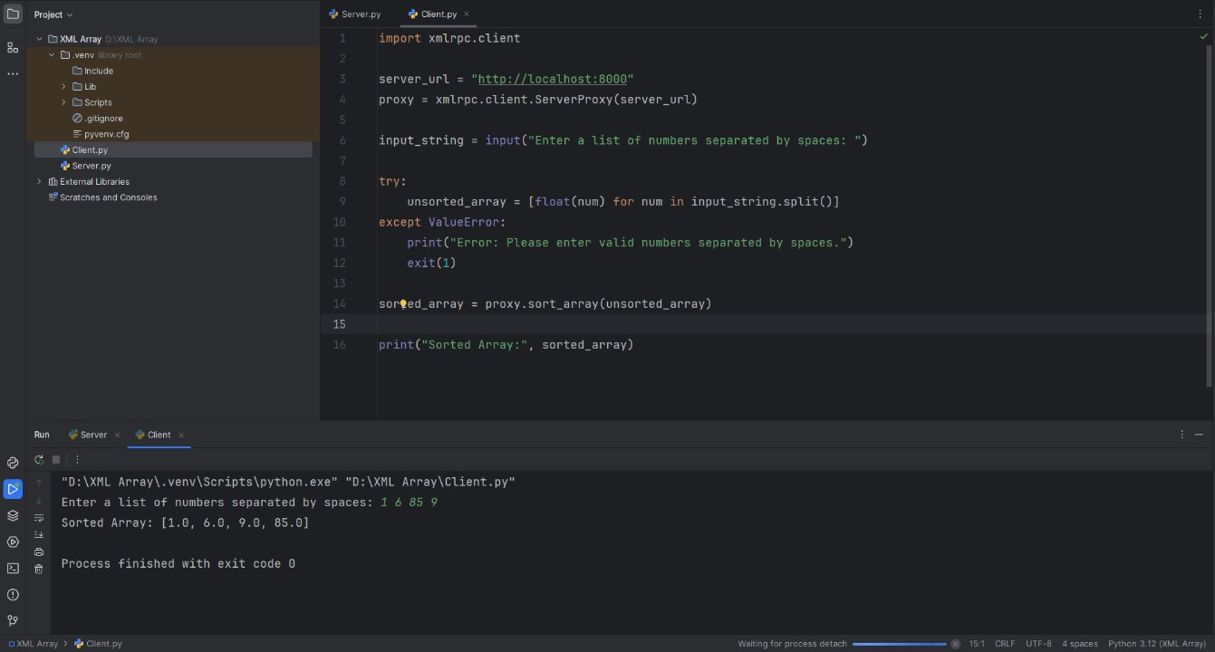

**Result:**

Thus, the soting of array using Remote Procedure Call was executed.